Jemima Adams Summary Paper
Jemima Adams
0477837526
Jemimaad02@gmail.com
U7301171@anu.edu.au

Jemima is an Art History student in her final year of a Bachelors in Art History and Curatorship at the Australian National University. She currently works in built history at the Old Parliament House and is interested in contemporary figurative art and printmaking.
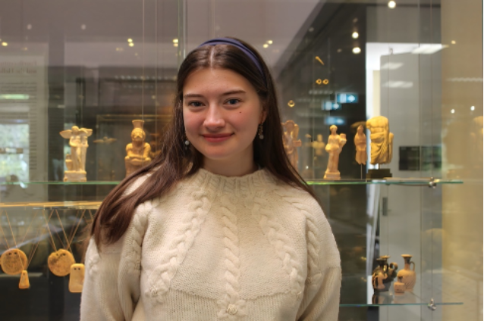

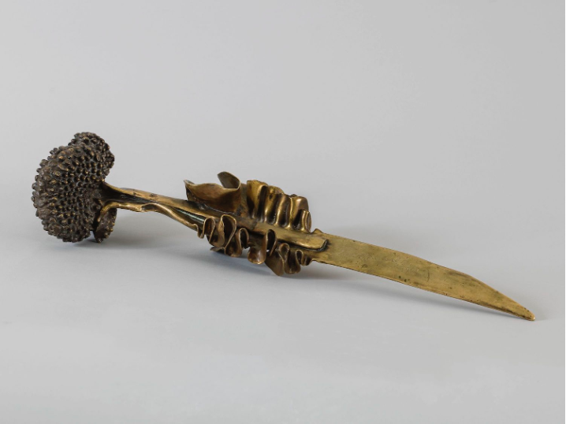
Sarah Bernhardt, Algues, 1900, patinated bronze, Photo Credit: Petit Palais, musée des Beaux-Arts, Paris Musées

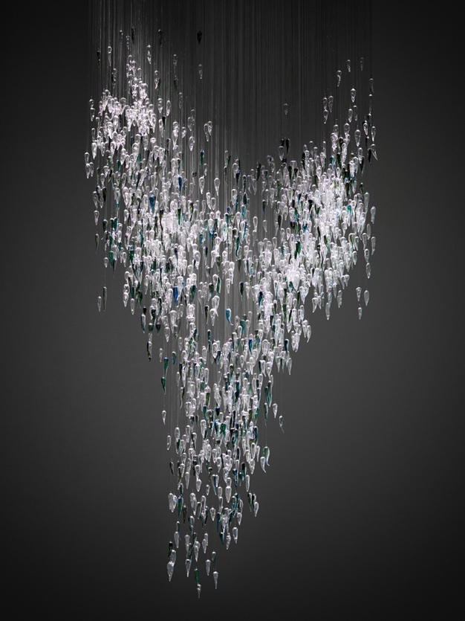
Yhonnie Scarce, Thunder Raining Poison, 2015, Glass assemblage, Photo Credit: National Gallery of Australia

  - Text
Both Sarah Bernhardt’s Algues and Yhonnie Scarce’s reflect nature’s dual capacity to nurture and destroy. The Art Nouveau movement captured just this, with the sinuous whiplash curve, evoking the spirit of nature’s defence. Algues and Thunder Raining Poison achieve this sense of the whiplash curve, beautiful yet dangerous, during the height of the Art Nouveau and then in a contemporary Australian Context. Through the lens of these two works, the inherent contradictions in the natural world emerge, and the human experience is bound up in these tensions, linking the past to the present, the personal to the collective.

Bernhardt, celebrated for her dramatic presence on stage, found solace in the wilds of the sea at Belle-Île-en-Mer, her chosen retreat. In Algues, she captures the fluid, sinewous forms of seaweed, rendering them in bronze with an elegant yet sharp precision. Cast with a green patina, the sculpture evokes both the fragility and latent threat of the ocean’s depths, embodying the Art Nouveau aesthetic of the "whiplash curve." Nature here is both restorative and ominous, a place where beauty and danger coexist. The dagger-like form embedded in the seaweed alludes to Bernhardt’s own theatrical experiences, merging her artistic life with the untamed forces of nature she sought refuge in.

In contrast, Scarce’s Thunder Raining Poison takes the imagery of the yam, a traditional bushtucker food, and transforms it into a stark symbol of cultural devastation. The glasswork, suspended in falling bombs, echoes the horrors of nuclear testing on Indigenous lands in South Australia. Scarce’s work contrasts the nourishing symbolism of the yam with its distortion into a weapon, a haunting metaphor for the destruction brought upon her people. The glass itself, reminiscent of the fused sand created by atomic blasts, deepens the emotional resonance of the piece, intertwining history with materiality.

Both Bernhardt and Scarce explore nature not merely as a source of beauty, but as a profound, conflicted force. Through their respective lenses, we see how nature’s embrace can simultaneously protect and threaten, a reflection of humanity’s eternal struggle to reconcile with its surroundings. The tension within their works reflects the timeless pull of nature, the very essence of the Art Nouveau spirit, where every curve hints at both creation and destruction.

