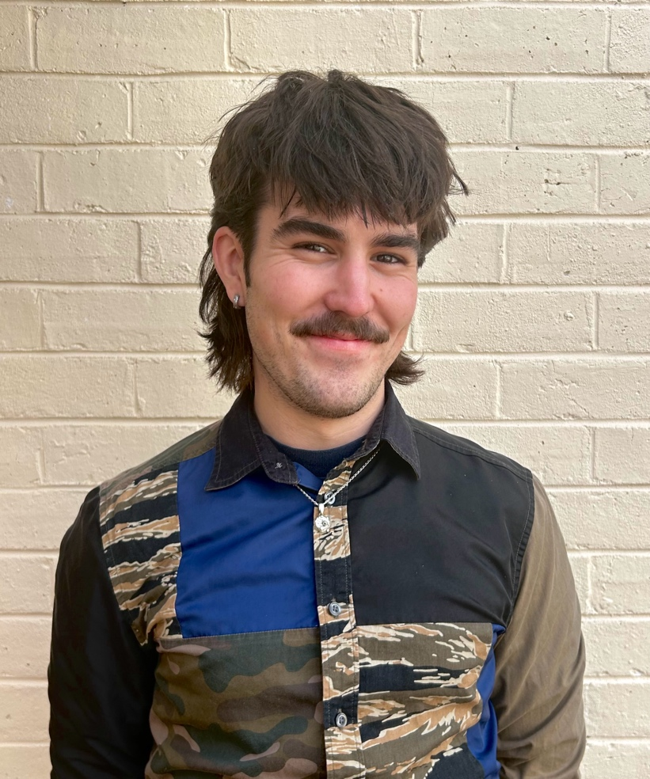

Self Intro
Daniel Glover is a third-year Art History major at the University of Western Australia. He is a member of the Lawrence Wilson Art Gallery’s student program Sculpt and serves as the History of Art Representative for the Student Society at the School of Design. These commitments reflect Daniel’s interest in community outreach and art’s capacity to contextualise and critique our image-saturated world.

Written Submission
Forged through a combination of air and fire, sand transforms into glass, a medium that is at once durable and fragile. A glass work becomes an evolving object through the reflecting and refracting of light that surrounds it, though always teeters on an edge, susceptible to death through breaking. French Art Nouveau artist Emile Gallé and Contemporary Kokatha and Nukunu artist Yhonnie Scarce explore this material state of tension through their glass work. Each artist combines this delicate aura with imagery of nature to communicate feelings of human anxiety. Paying tribute to nature through glass, both artists respond to concerns for the changing environments of their respective moments in their work.

Gallé was a participant in Art Nouveau, a design-led movement that aimed to implement stylistic representations of nature into an urbanising fin-de-siècle culture. Inspired by emerging psychological discourses that related nature to the human subconscious, Gallé produced art that provoked his viewer to consider and reconnect with nature and their inner being. The transient state of nature became the subject of Gallé’s œuvre, with the weaving of branches and veins of leaves embodying the human nexus of nerves and the mind. As such, the glass vessel becomes indicative of the body, glass a reminder of our similar fragility. Through these combinations of the natural, the human and the material, Gallé overarchingly reflects on mortality across his body of works.

Whilst Scarce is not responding directly to Gallé’s work, she is actively participating in this larger investigation of biological embodiment through glass. Like Gallé, Scarce is conscious of the provocative qualities of glass, as she suspends, pinches, and etches her works to spark a collective memory surrounding communal, traumatic events. Through the symbolic use of bushtucker, Scarce tenderly connects Indigenous food found in nature to her people and land, her artworks acting as both embodiments of and an offering to those she represents. By pushing the medium of glass to its limits, at times to the point of partial destruction, Scarce creates evocative forms that personify the rippling effects of colonial practices.

Where Gallé uses glass works to connect organic imagery to the human body and experience, Scarce sees glass as a way to contemplate specific moments of injustice that have slipped from national consciousness. By intimately wedding the human with the natural, the material with the intangible, the works of both artists become living objects, transmitting histories that speak to those that view them.

Word Count: 405

